# DBMS-2006 Final Project Milestone One Project Proposal

Developer Name: Raghav Sharma

Project Name: Auto-Parts warehouse inventory management system

Date: 20th Nov 2024

NOTE: Students are not permitted to have a project based on an academic environment (students, courses, books, instructors....). Project must be unique and cannot be anything that was used in this or previous courses. Students found using AI to generate the Project Proposal will receive an automatic zero grade for the project.

1. Project description:

This project will help to manage the inventory of an Auto-parts company at their main location.

Mainly to see price, quantity available in stock, company’s details of specific part, date on which the part was added in inventory and where it is located in warehouse (Aisle and shelf number) of all compatible vehicles with different makes (Toyota and Honda), models, types and manufacturing year from 2000 to 2025.

The reason I am doing this project is because my friend started his Auto-parts business in Winnipeg recently, this project will benefit him to manage and control his inventory at his warehouse. Also I can get real data with his help.

[Include a white horse in your description]

1. Business Case

This database project will help to view the stock of auto parts and all its details available in warehouse and will save time while fetching information like location of a particular part of all vehicle options available.

The target audience will be all auto-part shops, warehouses and auto mechanics as well.

1. Business Rules/Assumptions

* An Auto-part can fit in more than one (**one to many**) make and model of vehicle.
* A vehicle can have more than one particular type(company , category) of spare part compatible with it.
* A part can found only in one specific location(Aisle and shelf number)
* A location can have only one category of parts.
* An Auto-parts company can make Zero to many types and categories of parts.
* Parts for specific vehicle can be made by more than one company.
* A part category can have one to many parts in it.
* A part can only be in one category.

1. Entity Relationship Diagram

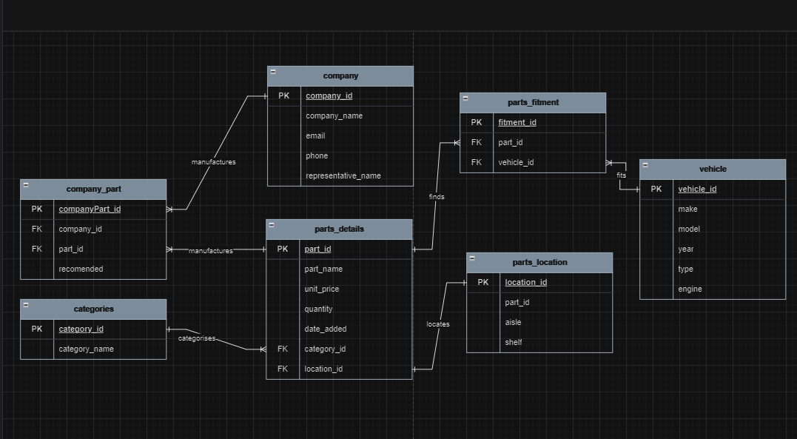

Parts_detail table has columns like part_id as primary key , part_name as name of the part, unit_price as price of single unit , quantity, date_added as on which date it was added in inventory , category_id as foreign key joining catrgories table and location_id as second Foreign key joining part_location table.

Categories table has 2 columns one is primary key and other one is name of the category which will store the type of auto_part e.g. brakes, fender, spoiler etc. This table has one to many relation with parts_details table as one category can have many parts but one part can only in one category.(e.g. front brakes and rear brakes both in braked category)

Parts_location table has columns like location_id, part_id as Foreign Key , aisle and shelf number to find the location of part in warehouse. This table has one to one relation with parts_detail table as one type of part can be located at on location only.

Tables company and vehicle were having many to many relation with parts_detail table , so to solve this company_part and parts_fitment were added as a bridge table and helps to find which manufacturer’s part is the best , cheap and recommended.

Company table has columns like company_id as PK , company_name as the part manufacturer’s name , email , phone and representative_name as the company’s contact details.

This table has one to many relation with company_part table which acts as bridge table with parts_detail table

Vehicle table has columns like make ,model, type, engine and year which will help to find which part fits best to every table according to its matching specifications.

Parts_fitment table acts like bridge between vehicle and part_detail table helps to find which part is suitable for perticular vehicle according to its specifications mentioned above.